Slices of a Three Dimensional Matrix

We will return to the matrix that we saw earlier, along with an indication of the values that we could not see then.

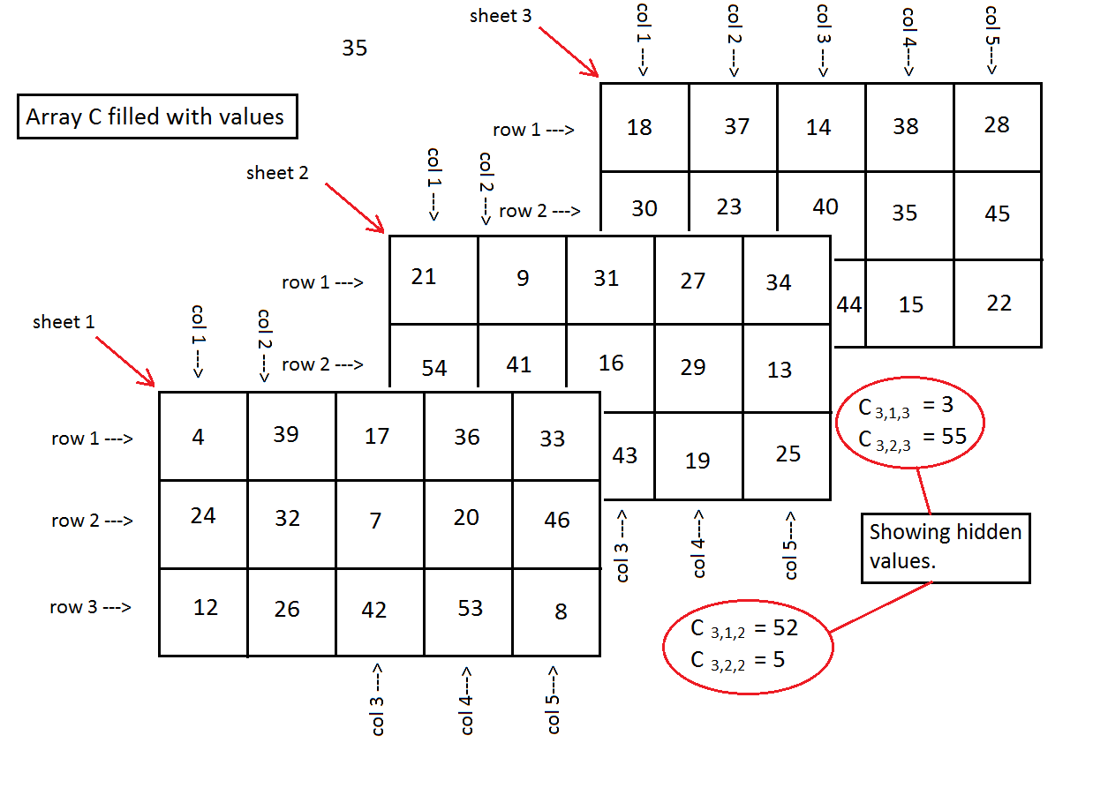

Our interest here is to take slices of that array. Any such slice holds one of the indices constant. The most obvious slice is one where we hold the sheet index, k in Ci,j,k, constant. For example, if we look at sheet 2, by itself, then we get a 2-dimensional array that looks like:

|  |  |  |  |  |
| --- | --- | --- | --- | --- |
| 21 | 9 | 31 | 27 | 34 |
| 54 | 41 | 16 | 29 | 13 |
| 52 | 5 | 43 | 19 | 25 |

On the other hand, we might want to take a slice of the array where we hold a column constant. That would mean that we hold the subscript j constant in Ci,j,k. In our example, if we look just at column 2 we get a 3x3 matrix of values, namely

|  |  |  |
| --- | --- | --- |
| 39 | 9 | 37 |
| 32 | 41 | 23 |
| 26 | 5 | 55 |

Finally, we might hold a row constant, that is hold the i in Ci,j,k constant. In our example, just looking at the third row gives as a 5x3 matrix, namely

|  |  |  |
| --- | --- | --- |
| 12 | 52 | 3 |
| 26 | 5 | 55 |
| 42 | 43 | 44 |
| 53 | 19 | 15 |
| 8 | 25 | 22 |

This last example, taking a slice that holds a row constant, is often seen as being an awkward view of the slice. Why not represent the slice as the 3x5 array

|  |  |  |  |  |
| --- | --- | --- | --- | --- |
| 12 | 26 | 42 | 53 | 8 |
| 52 | 5 | 43 | 9 | 25 |
| 3 | 55 | 44 | 5 | 22 |

The advantage of the 5x3 arrangement is that it preserves the original context of a 3x5x3 array. In the original it was (row)x(column)x(sheet). If we hold the row constant then we are really looking at the (column)x(sheet) array and that is a 5x3 array. What makes it look awkward is that the original columns now become rows.